Recursion

Programming with recursion
Recursion is a method that calls itself.
- A classic example is the factorial function:
n! = 1 x 2 x 3 x … x (n-1) x n (let 0! = 1)
- 0! = 1
1! = 1
2! = 2 (= 1 x 2)
3! = 6 (= 1 x 2 x 3)
4! = 24 ( = 1 x 2 x 3 x 4)
…
10! = 3628800 (the number of permutations of 10 elements)
- The recursive function is:
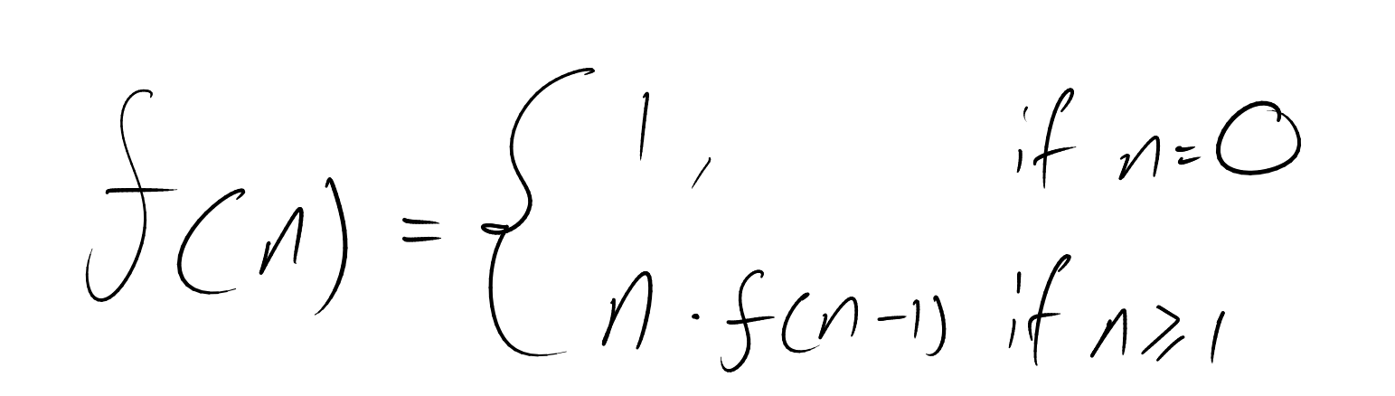

- As a Java method:
public static int recursiveFactorial(int n)
{
if (n <= 0) return 1;
else return n * recursiveFactorial(n – 1);
}

Visualising recursion
We can trace recursion:
- A box for each recursive call
- An arrow from each caller to callee
- An arrow from each callee to caller showing the return value
public static int recursiveFactorial(int n)
{
if (n <= 0) return 1;
else return n*recursiveFactorial(n – 1);
}
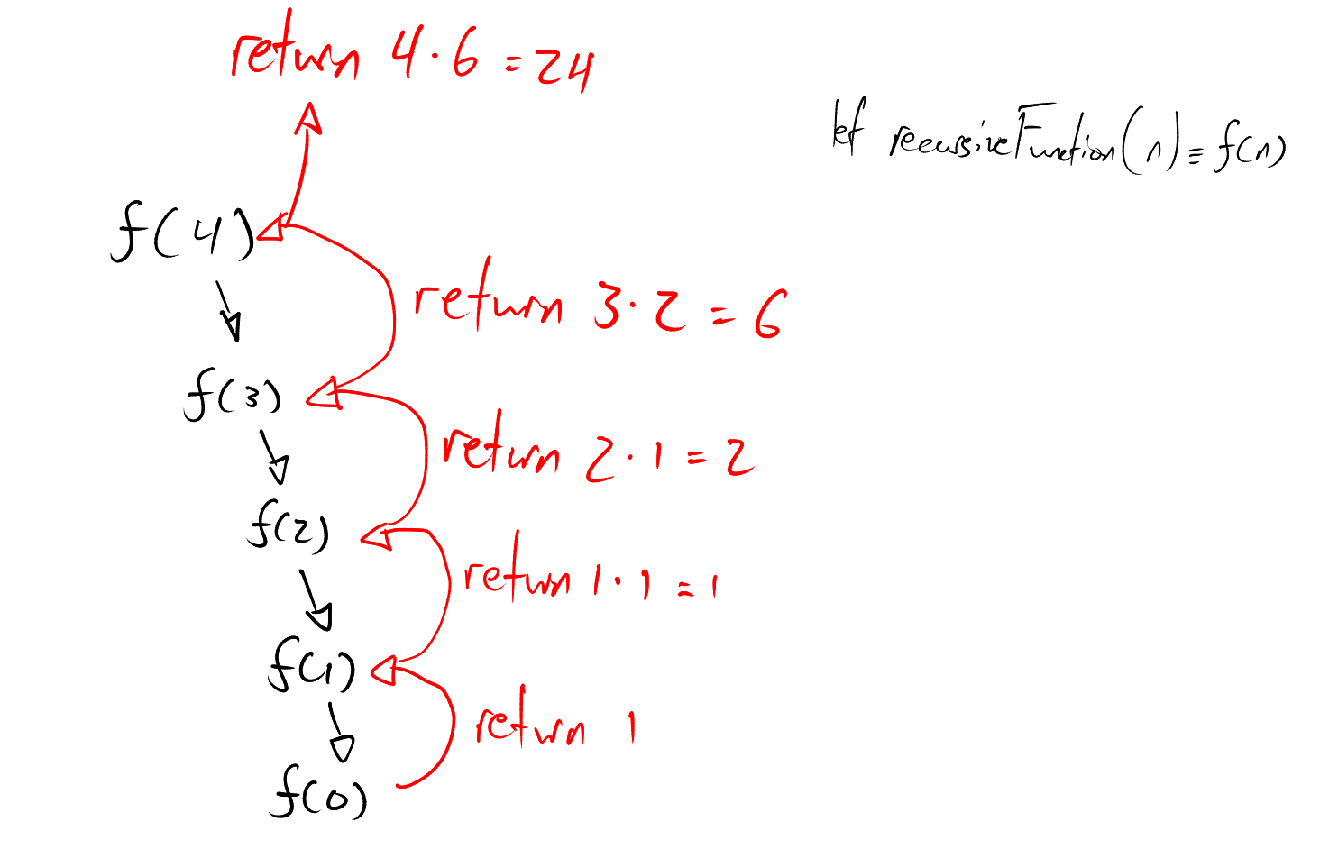

We could also do an interative solution:
public static int iterativeFactorial(int n)
{
int result = 1;
for (int i = 1; i <= n; i++) {
result = result * i;
}
return result;
}
In general, recursion takes up more memory and is less intuitive to program, so why would we use recursion?
Because in some use cases, recursion is more intuitive to program.

Content of a recursive method
- Base case(s)
  - Values of the input variables for which we perform no recursive calls are called base cases (there should be at least one base case).
  - Every possible chain of recursive calls must eventually reach a base case.
- Recursive calls
  - Calls to the current method
  - Each recursive call should be defined in such a way that it makes progress towards a base case.

Linear recursion
- Test for base cases
  - Begin by testing for a set of base cases (there should at least be one).
  - Every possible chain of recursive calls must eventually reach a base case, and the handling of each base case should not use recursion.
- Recur once
  - Perform a single recursive call
  - This step may have a test that decides which of several possible recursive calls to make, but it should ultimately make just one of these calls.
  - Define each possible recursive call so that it makes progress towards a base case.

Defining arguments for recursion
In specifying a recursive method, it is important to define the method I na way that facilitates recursion.
- This sometimes requires we define additional parameters that are passed to the method.
- For example, even if we only want to reverse whole arrays, we still define the array reversal method as ReverseArray(A, i, j), not ReverseArray(A)
- Method for reversing the whole array:
public static void reverseArray(Object[]A){
reverseArray(A, 0, A.length-1);
}

Computing Powers
- The power function, p(x,n) = x^{n}, can be defined recursively:
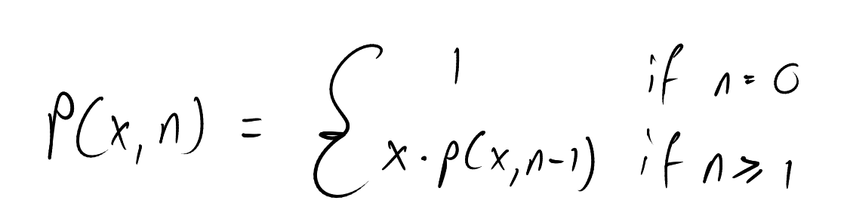

- This leads to a power function that runs in time linear to n (since we can make n recursive calls; n multiplications)
- We can do better than this.

Recursive squaring
For example,
2⁴ = 2 x 2 x 2 x 2 = 16
= (2²)² = 4² = 16
2³² = 2 x 2 x 2 x … x 2 = 4,294,967,296
= (2¹⁶)² = ((((2²)²)²)²)² = …
2¹⁴ = 2 x 2 x 2 x … x 2 = 16,384
= (2⁷)² = (2 x 2⁶)² = (2 x (2³)²)² = 2 x (2 x 2²)²)² = …
Therefore, we can apply it in this function:
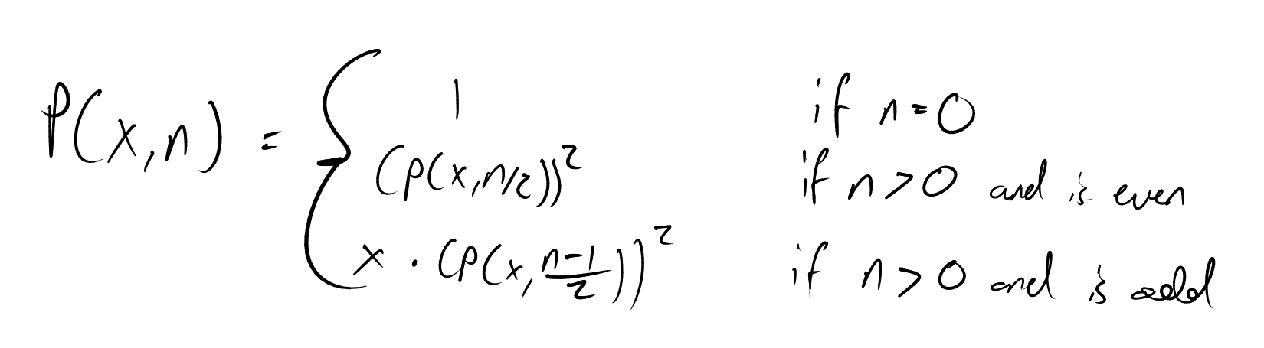

Example:
x¹⁴ = P(x, 14) = [p(x,7)]² = [x * [p(x, 3)]²]² = [x * [x * [p(x, 1)]²]²]²
= [x * [x * [x * [p(x, 0)]²]²]²]²

Tail recursion
Tail recursion occurs when a linearly recursive method makes its recursive call as its last step.
- The array-reversal method is an example.
- Such methods can easily be converted to non-recursive methods (saving on some resources).
Example:
Algorithm IterativeReverseArray(A, i, j):
Input: an array A and non negative integer indices i and j.
Output: The reversal of the elements in A starting at index i and ending at index j
while i < j do
Swap A[i] and A[j]
i = i + 1
j = j – 1
return

Another Binary Recursive method
Problem: Add all numbers in an integer array A:
Algorithm BinarySum(A, x, n):
Input: An array A and integers x >= 0 and n >= 1
Output: The sum of the n integers in A starting at index x
if n = 1 then
return A[x]
return BinarySum(A, x, [n/2]) + BinarySum(A, x + [n/2], [n/2])
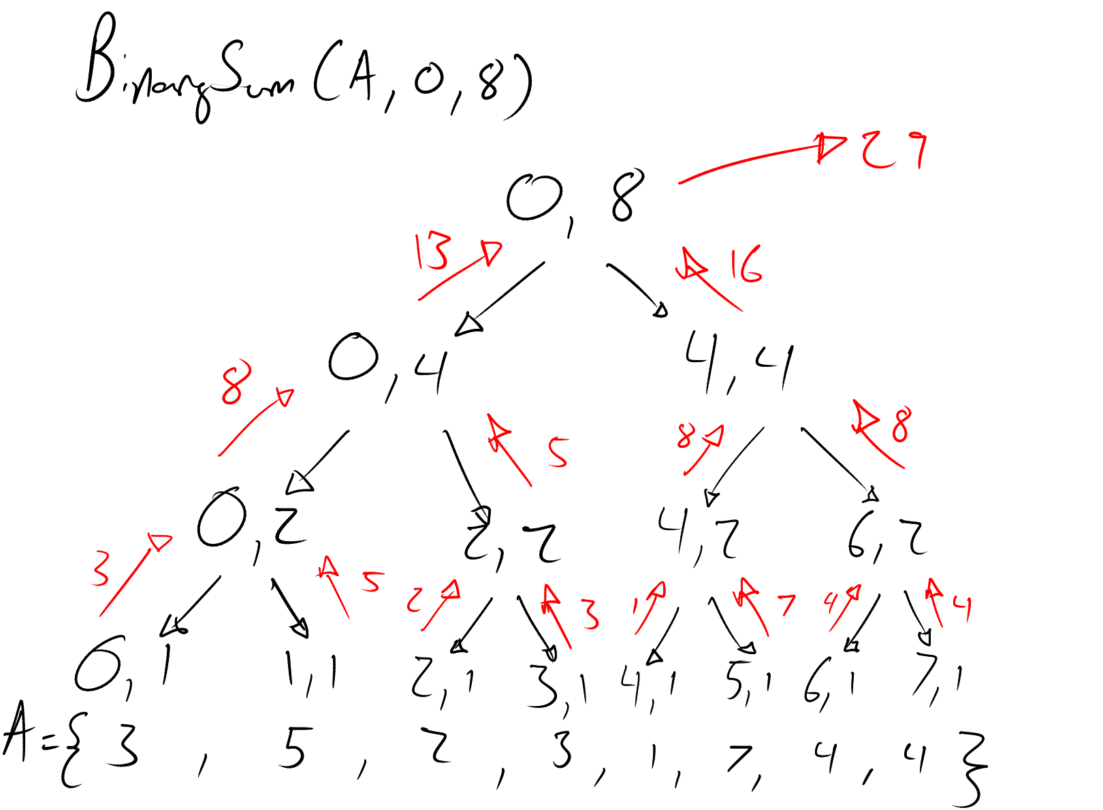

Computing Fibonacci numbers
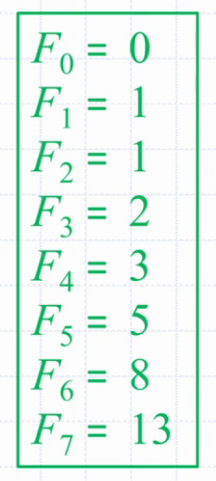
Fibonacci numbers are defined recursively:
F₀ = 0
F₁ = 1
F_{i} = F_{i-1} + F_{i-2} for i > 1.
Recursive algorithm (first attempt):
Algorithm BinaryFib(k):
Input: Nonnegative integer k
Output: The k-th Fibonacci number F_{k}
if k <= 1 then
return k
else
return BinaryFib(k-1) + BinaryFib(k-2)

Inefficiency
This recursive method is very inefficient. There are many repetitions of the same computation.
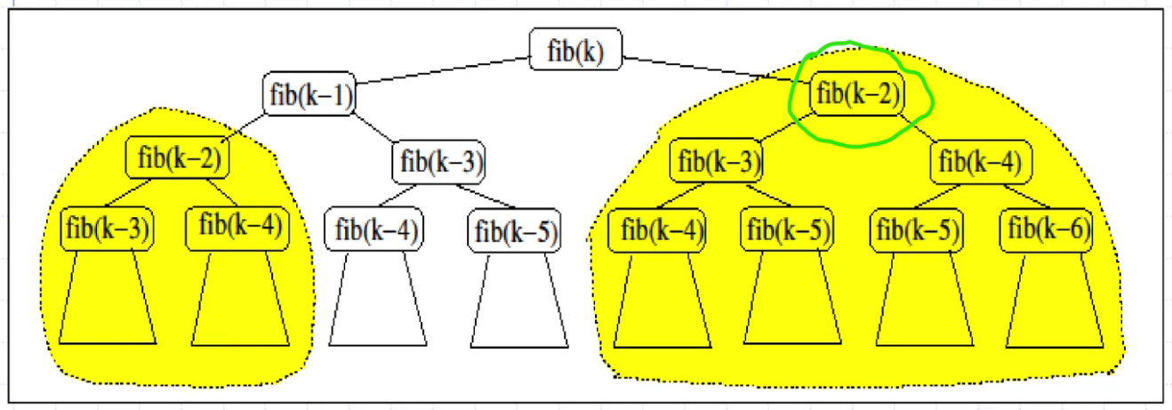

Use linear recursion instead!
Algorithm LinearFib(k):
Input: An integer k >= 1
Output: Pair of Fibonacci numbers (F_{k}, F_{k-1})
if k <= 1 then
return (k, 0)
else
(i, j) = LinearFib(k – 1)
return (i + j, i)
LinearFib(k) makes k-1 recursive calls, whilst BinaryFib(k) makes at least 2^{k/2} recursive calls.
In Java:
public static int iterFib(int n)
{
if(n <= 1) return n;
else {
int previous = 0;
int current = 1;
int next;
for (int i = 2; i <= n; i++) {
// current is fib(i-1); previous is fib(i-2)
next = current + previous;
previous = current;
current = next;
}
return current;
}
}
Linear recursion is very fast to compute compared to binary recursion, but in general iterative computation is faster. In other words, avoid recursion when you can as it takes time and memory (valuable resources!)

Multiple recursion
Take for example summation puzzles – replace letters with digits (same letter – same digit) to make the equation true:
- pot + pan = bib
- dog + cats = foes
Multiple recursion:
- potentially many recursive calls
Algorithm PuzzleSolve (k, S, U)
Input: Sequence S: digits fixed for the initial letters
Integer k: the numer of remaining letters,
Sequence U: (the digits to test for the remaining letters)
e.g. find solution (a=7, b=3, i, n, o, p, t): PuzzleSolve (5, (7, 3), {0,1,2,3,4,5,6,8,9})
Compute: Generate and test k-length textensions of S using digits U without repetitions, until a solution to the puzzle is found.
if k = 0 then
Test whether S is a sequence that solves the puzzle
if S solves the puzzle then print(“Solution found: “, S) and terminate
else
for all e in U do
Remove e from U
Add e to the end of S
PuzzleSolve(k-1, S, U)
Remove e from the end of S
Add e back to U
